**SOFE 3490U Laboratory PROJECT: LAB 3**

Durreshahwar Arif (100587401)

Ibaada Arif (100655270)

Matthew Brown(100670025)

**STEP 1 - PROJECT ESTIMATION USING FUNCTION POINTS**

|  |  |  |  |  |  |  |  |
| --- | --- | --- | --- | --- | --- | --- | --- |
|  |  |  | **Complexity** |  |  |  |  |
|  | **Low** |  | **Medium** |  | **High** |  |  |
| **Description** | **Estimate** | **\*** | **Estimate** | **\*** | **Estimate** | **\*** | **Total** |
| **Inputs** |  | **3** | **20** | **5** |  | **7** |  |
| **Outputs** |  | **4** | **20** | **4** |  | **6** |  |
| **Inquiry Outputs** |  | **4** | **20** | **5** |  | **7** |  |
| **Inquiry Inputs** |  | **3** | **15** | **4** |  | **6** |  |
| **Files** |  | **7** | **4** | **10** |  | **15** |  |
| **Interfaces** |  | **5** | **4** | **7** |  | **10** | **408** |

|  |  |
| --- | --- |
| **Environmental Factor** | **Rating** |
| **Data Communications** | **4** |
| **Distributed Computing** | **3** |
| **Performance Requirements** | **5** |
| **Constrained Configuration** | **3** |
| **Transaction Rate** | **3** |
| **Online Inquiry and/or Entry** | **1** |
| **End-User Efficiency** | **5** |
| **Online Update** | **4** |
| **Complex Processing** | **4** |
| **Reusability** | **1** |
| **Ease of Conversion/Install** | **1** |
| **Used at Multiple-Sites** | **1** |
| **Potential for Future Change** | **3** |
| **Total Environmental Factor** | **38** |
|  |  |
| **Complexity Adjustment Factor** | **1.03** |
|  |  |
| **Adjusted Function Points** | **420** |

**LOC for Java is roughly 40 - 80.**

**LOC = 420 * 80 = 33600 LOC**

**E = a(KLOC)b**

**This project could be described as a semi detached. It is not entirely large and not extremely complex.**

**E = 2.4(33.6)1.12**

**= 123 person-months**

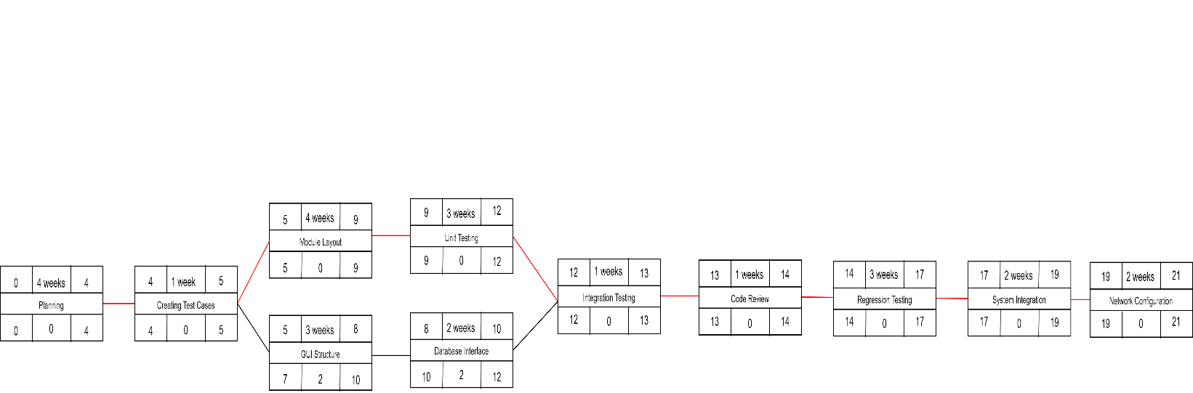**PART 2 - Activity Chart**

**Part 3 - Risk Management**

* **The main risk with our course management system is integration. Since we are porting a new application in an existing one, we must make sure that it does interfere with the current programming ordinary system**
* **Another risk is resistance to change. When adding extended functionality to a course management system, the dispute could be the initialization of the project worth it? It is important to outweigh the benefits rather than costs. Our project is viable and most definitely feasible**
* **The final risk is the resource risk. The project timeline is not very long and we do not necessarily require a large team, but a skilled team. Meeting deadlines is important and we need to have the resources to meet them**